**Step 1 – Download latest Z370C/CG image, demo app and offline content from the website**

<http://www.asus.com/microsite/demo/Asus_ZenPad_7.htm>

**Step 2 – Update the Z370C/CG system image**

If the device image version is not V12.26.5.17 or above, please follow below steps to update the correct image.

If the device is correct image version, please go to step 3.

1. Copy image zip file to SDCard and put into device.

* Z370C WW : UL-P01W-WW-12.26.5.17-user.zip
* Z370C JP : UL-P01W-JP-12.26.5.17-user.zip
* Z370CG WW : UL-P01V-WW-12.26.5.17-user.zip

1. Click the home page left-top corner exclamation mark “” to start the system update. (10~15 minutes)

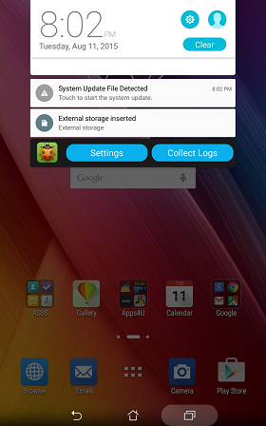

**Step 3 - Update demo apk**

1. Copy “AsusLiveDemoService2_Permission.signed_SW123.apk” to your device’s internal storage.

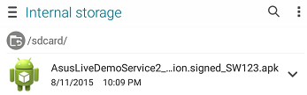

1. Click the “AsusLiveDemoService2_Permission.signed_SW123.apk” to install the app.
2. Restart device.

**Step 4 - Offline Content update**

1. Copy “APD_offline_Z370.zip” to your device’s internal storage (make sure only one zip file in your device)

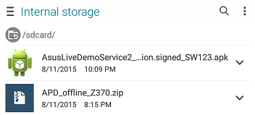

1. Key in the password in calculator app cid:image002.png@01D0A74B.F81BED70 to turn on demo app.

(Enter pin code: [πeπe741603eπeπ] and tap [=] to trigger demo app.)

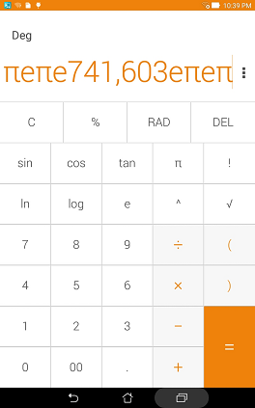

1. Key in the password in calculator app cid:image002.png@01D0A74B.F81BED70 to turn on demo app **again**.

(Enter pin code: [πeπe741603eπeπ] and tap [=] to trigger demo app.)



1. If pop up below warning message, choose [OK]

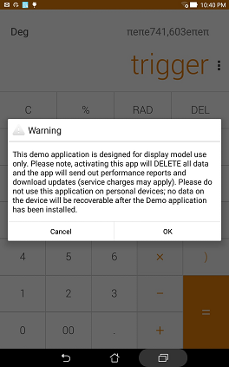

1. Enter the pin code: [**741603**] when below warning message pop up

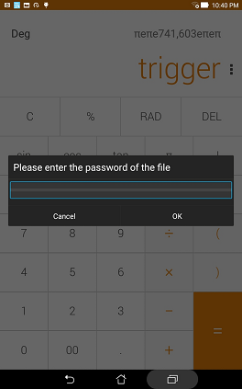

1. Wait for update and finish. (3~5 minutes)