ASUSTek Computer Inc.
ASUS Demo 2.0
[Installation SOP]

Models: A86, ME372CG, TF701T, ME180A, ME102A, ME175KG, ME173XX, PF400, A400, A500, A600, ME372CL, FE170CG,TF103C & coming models
2014/4/1

Chapters

- ASUS Demo 2.0 Introduction
- Online Installation & Registration
- Offline Installation & Demo Device Data Collection
- Demo App Deactivation
- Demo App Additional Function: Promotion Page Setting

ChapterⅠ
ASUS Demo 2.0 Introductions

- Overview & Mission:
Asus Demo aims to provide an incredible shopping experience to our customers. It is an application which can let each Asus product tells a unique story about itself. The content highlights diverse features of each model, and it can make users easily understand what kind of benefit they can gain from Asus technology.
The demo app is used for demonstration purpose only. Before the implementation of each model, Asus manager should plan ahead in eCommerce that means knowing which store (company ID) is going to execute online demo and which is going to do offline demo.

- Features of Demo 2.0:
- Demo content has preloaded to all MP devices, including photos, videos & dummy data (contact list, call log, SMS & e-mail).
- Press power button to play screensaver or it runs automatically within 30 seconds.
- Auto setting improvement: brightest screen, turn on Wi-Fi, daily reboot, lock back up & reset, hourly wipe out unnecessary data and customize promotion page set up.
- Simplified installation. First to start offline demo mode by key in the password in calculator app 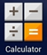 to turn on demo app. Then, if the device can be linked to Wi-Fi, key in a “demo unit code” to connect Asus server to change online demo mode. Once the demo unit successfully registered in Asus server, it will be locked within the program days that planned.
- Factory reset locked. (A demo device has only one way to execute factory reset and deactivate demo app: press back key on the main page for 10 second until you see a black page to key in the password).

Note: Before starting the implementation, demo program manager must log in eCommerce to generate a unique demo unit code for each online demo device from “Demo Machine Plan.” Please refer to the SOP link:
ChapterⅡ
Online Installation & Registration (from Demo Unit)

NOTICE! If the demo device can be connected to wifi in store, there are two ways to link demo app to Asus server. The first way is from Demo Unit:
Step 1  [Setting] | 1) Boot up the demo unit and make sure the device is charged with adapter  2) Make sure the demo unit is connected to wifi:  Pull down the task bar select an available wifi provider in store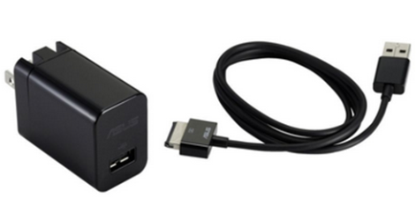 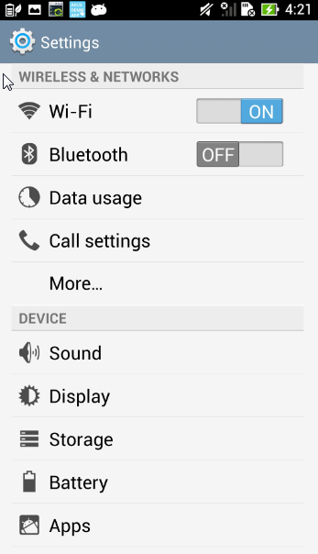
Step 2  [Trigger] | 3) Tap [APPS] icon on desktop  4) Tap [Calculator]  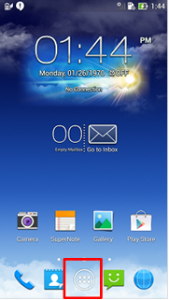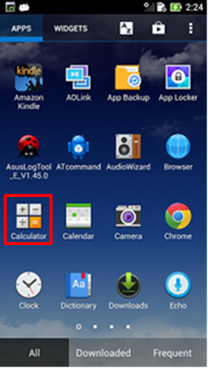
ChapterⅡ
Online Installation & Registration (from Demo Unit)

Step 2  [Trigger] | 5) Enter pin code: [πeπe741603eπeπ]  6) Tap [=] to trigger demo app  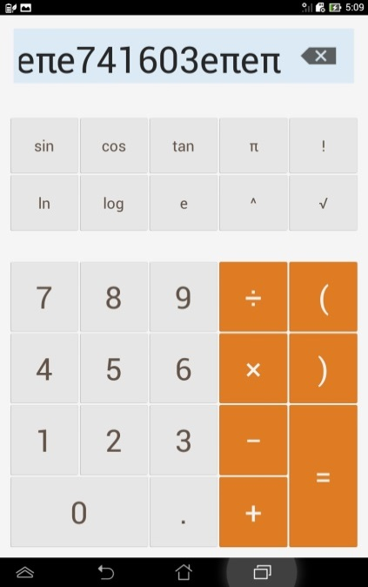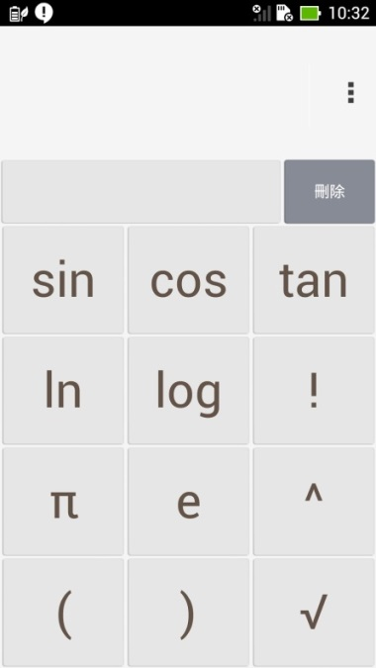
 | 7) Choose [OK] Welcome to Asus Demo 2.0!
ChapterⅡ
Online Installation & Registration (from Demo Unit)

Step 3  [Register] | 8) Tap right-down corner “menu” icon  9) And tap [Register] to connect Asus server  10) Key in this device’s [demo unit code] Submit to check!  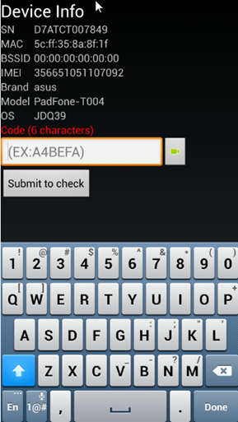  1.  2.
11) Tap [Confirm]. Check if the device successfully registers to Asus server Pull down the [task bar] to check the status of demo device is “online.” And go to eCommerce to double check the demo device’s status shows “Active.”
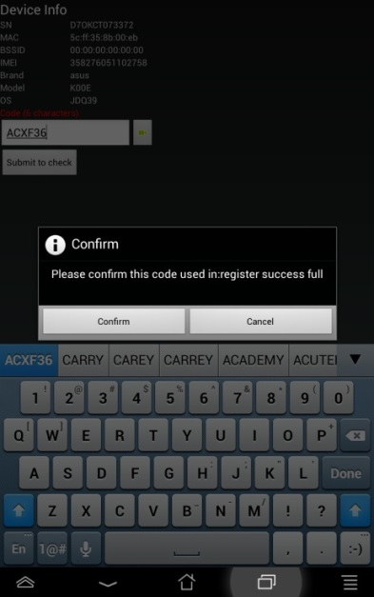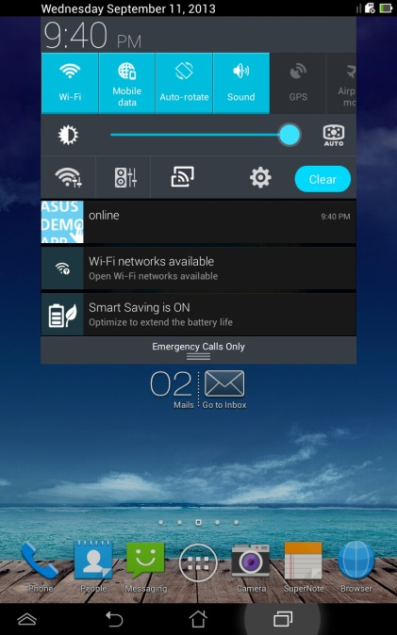
ChapterⅡ
Online Installation & Registration (from eCommerce)

NOTICE! If the demo device can be connected to wifi in store, there are two ways to activate live demo to Asus server. The second way is remote trigger from eCommerce, and only Asus employee is allowed to do the implementation:
- Log in eCommerce [Demo Machine Plan]

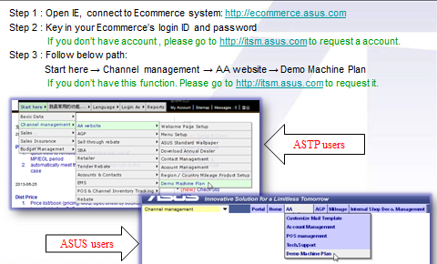

- Upload your “demo machine plan” excel file and follow the steps

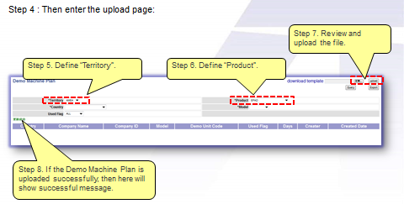

ChapterⅡ
Online Installation & Registration (from eCommerce)

3) Query “non-used” demo machine plan
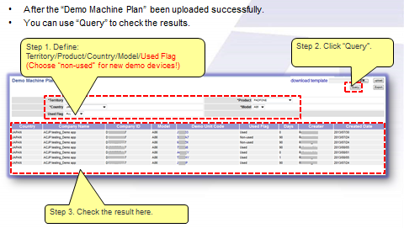

4) Click “demo unit code” to key in the device’s serial number & mac address. (Before key in, please call the store to confirm that demo device is connected to Wi-Fi) Click [save] to activate demo device connect to eCommerce.
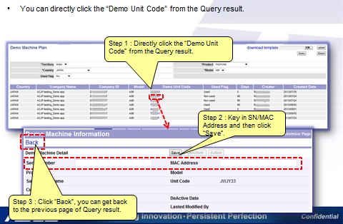

ChapterⅢ
Offline Installation & Demo Device Data Collection

Step 1  [Trigger] | 1) Boot up the demo unit and make sure it is charged with adapter  2) Tap [APPS] icon on desktop  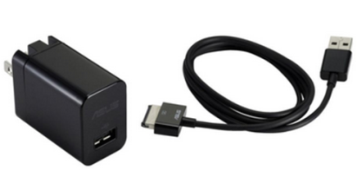
3) Enter pin code: [πeπe741603eπeπ]
4) Tap [=] to trigger demo app

ChapterⅢ
Offline Installation & Demo Device Data Collection

Step 1  [Trigger] | 5) Choose [OK] Welcome to Asus Demo 2.0!
Step 2  [Collect Data] | 6) Tap right-down corner “menu” icon  7) And tap [pre-Register] for offline registration  1.  2.

ChapterⅢ
Offline Installation & Demo Device Data Collection

Step 2  [Collect Data] | 8) Fill in all the information requested below  9) Put micro SD card into the device and tap [save to sdcard]  10) Go to [File Manager] to find the data you key in the demo device  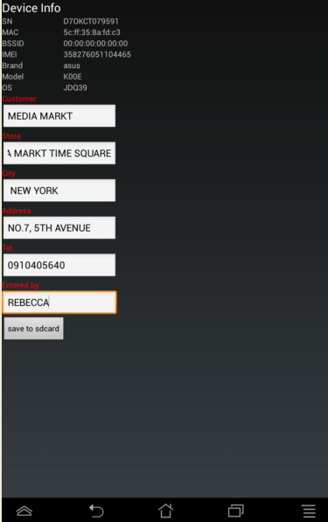
Step 3  [Save Data] | 11) The .csv file can be found in [Internal Storage] or [Micro SD]  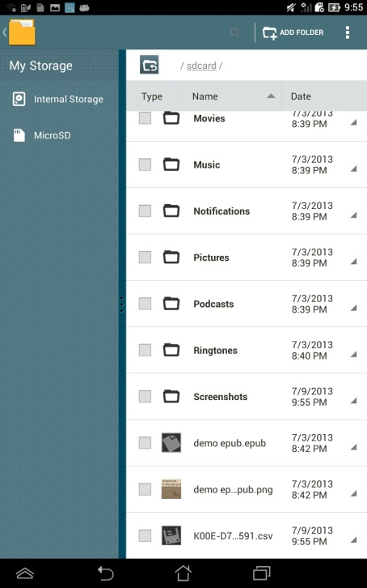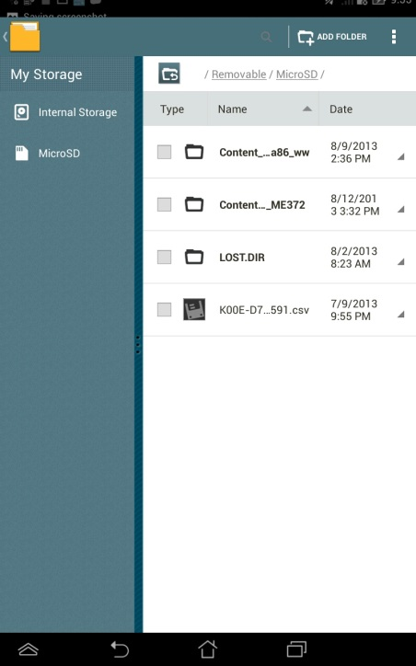
ChapterⅢ
Offline Installation & Demo Device Data Collection

Step 3  [Save Data] | 12) Please collect the [.csv ] file and report it to your Asus manager.  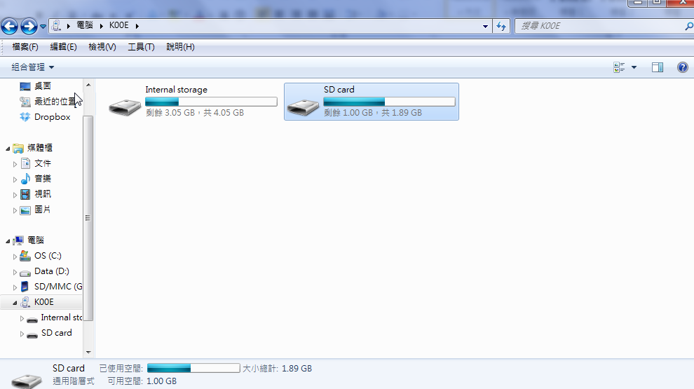  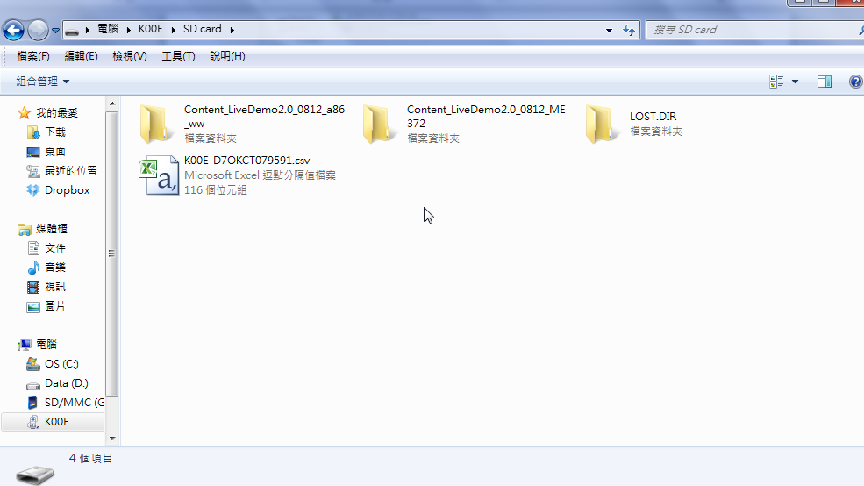

ChapterⅣ
Demo App Deactivation (from device)

NOTICE!
- Store must report to its ASUS Manager before delete Asus demo.
- For online demo device, it must connect to Wi-Fi while doing deactivation. Once you key in the pin code, demo app will be deleted and changed its status in eCommerce. Also, the device will execute factory reset automatically. (The whole process may take about 5 minutes).
- ASUS manager can also execute remote deactivation of online demo device from eCommerce.
1) Click [power button] to play demo video then tap the screen to the main page
2) Stay on the main page and press/hold [back key ] for 10 seconds until you see a black page to key in the password
3) Key in password [741603] and tap [confirm] Auto reset, deactivation succeed!
4) Go to eCommerce: Double check if this device’s status become “DeActive”
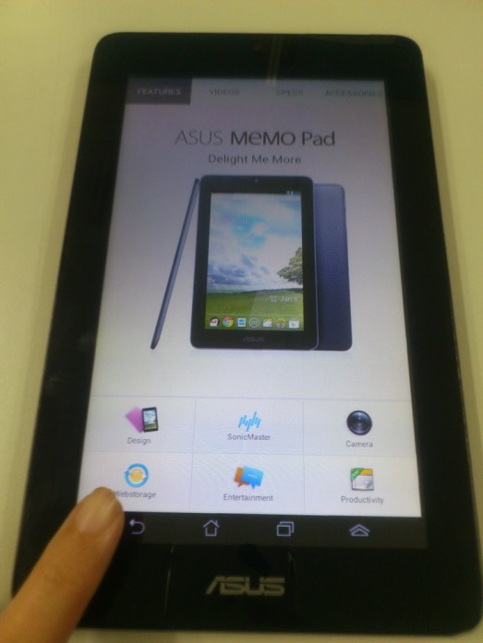
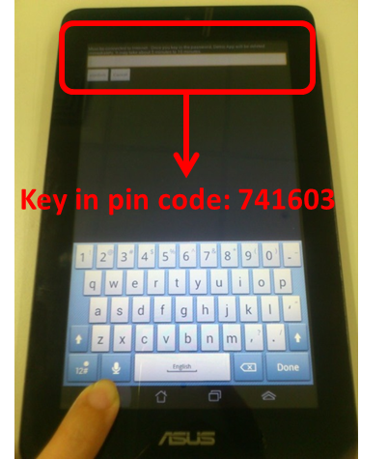

ChapterⅣ
Demo App Deactivation (from eCommerce)

- ASUS manager can also execute remote deactivation of online demo device from eCommerce.
1) Go to http://ecommerce.asus.com.tw/, [Account Management]
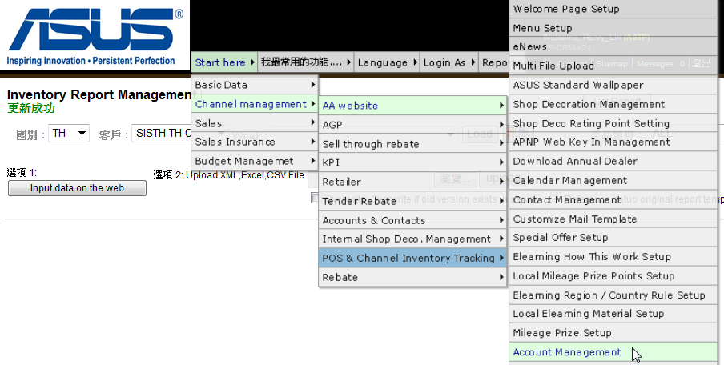

2) Select [Approve dealer][Country][Company ID]

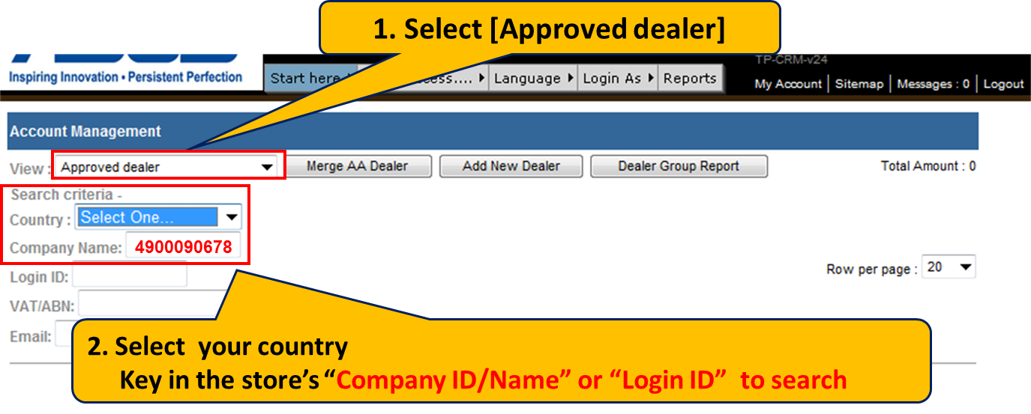

ChapterⅣ
Demo App Deactivation (from eCommerce)

NOTICE!
- Demo device must connect to Wi-Fi while doing deactivation.
- Once you click [DeActive], eCommerce will send the requested deactivate order to the demo device. If the internet connection works perfectly, the device will be reset immediately. And its status in eCommerce will change from Active to DeActive.
3) Find your demo device which you want to deactivate, and click into [Edit]
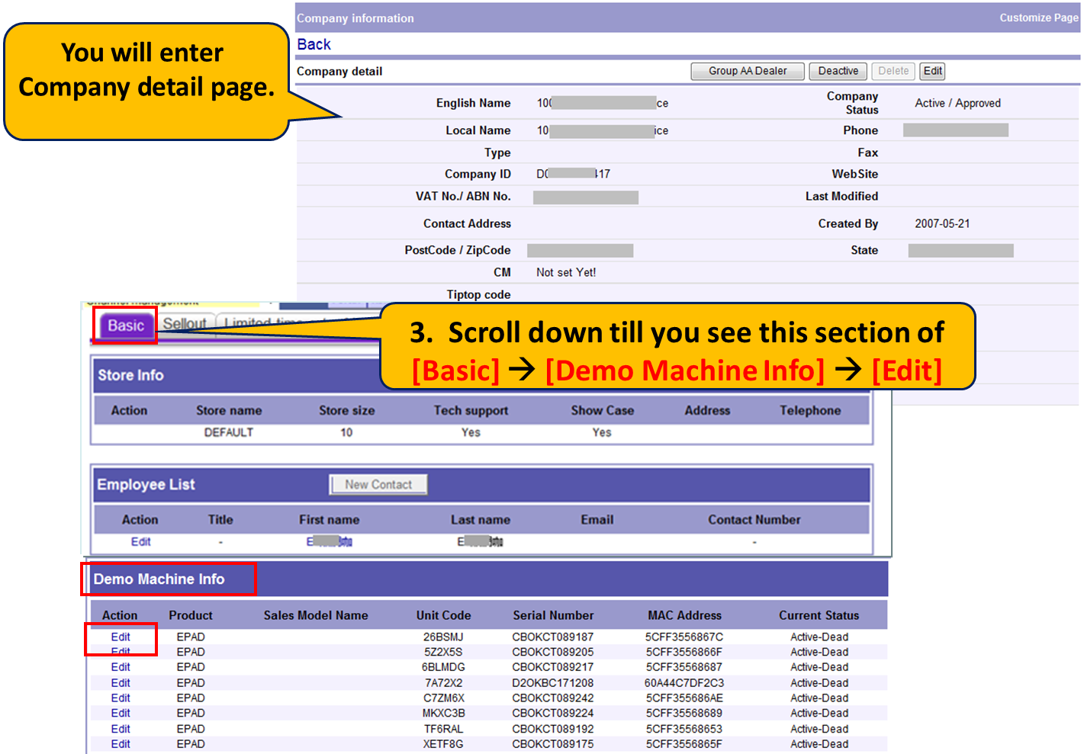

4) Click [DeActive]
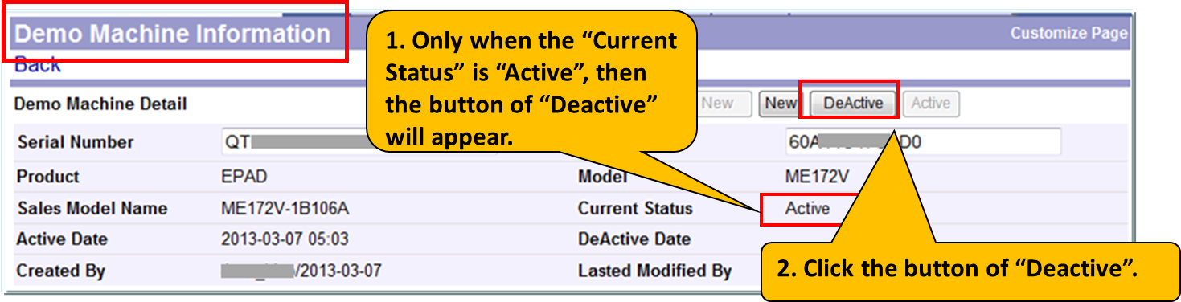
ChapterⅣ
Demo App Deactivation

NOTICE!
- Demo device must connect to Wi-Fi while doing remote deactivation.
- Once you click [DeActive] button, eCommerce will send the requested deactivate order to the demo device. If the internet connection works perfectly, the device will be factory reset immediately. And its status in eCommerce will change from Active to DeActive.
5) Request DeActive order sent
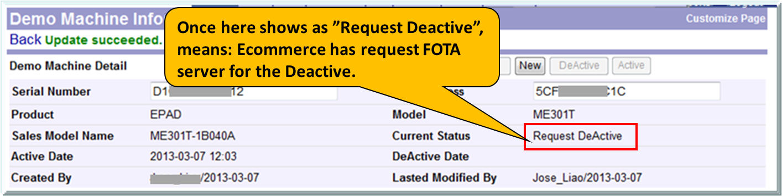

6) DeActive Succeed!
(Check with the store if the demo device indeed execute factory reset! )

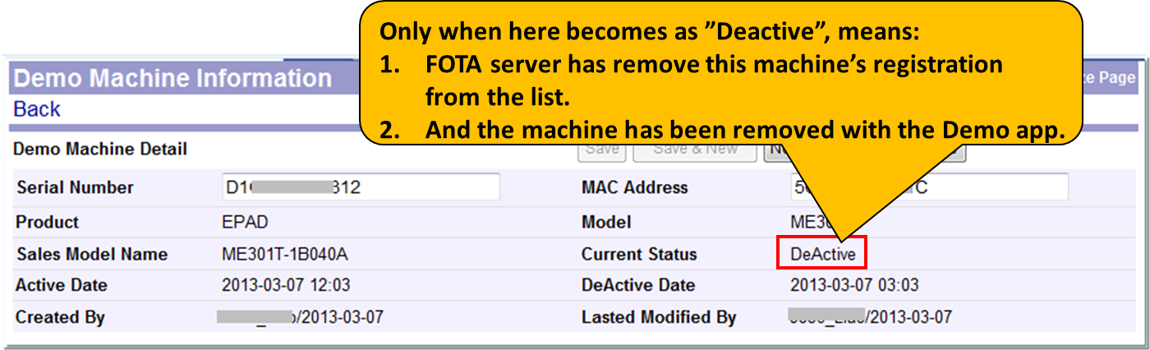

ChapterⅤ
Demo App Additional Function: Retailer Customize Settings
NOTICE!
In order to enlarge the flexibility of diverse channel promotion & localization, Asus sales and promoters can use demo app to edit the demo contents
1) While demo video is playing, tap the screen and go to demo main page
2) Tap right-down corner icon tap [Settings] key in pin code [741603] OK

3) There are 3 sections for [Retailer Customize Settings]
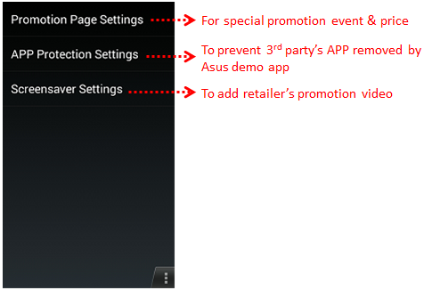

- Choose [Promotion Page Settings]

Click [Enable] and start to edit the required information [Save] Go back to the demo main page; you shall see the displayed information.

- Choose [App Protection]
Demo app is built to hourly remove unnecessary applications. If the retailer/channel wants to keep its own APP and prevent to be deleted, select the specific APP and tap [OK] so it will maintain in this device.

  - Choose [Screensaver settings]

This function is open to retailer/channel to select its own promotion video to play after Asus screensaver video. Please first put the retailer/channel promotion video into demo device’s internal storage go to demo app main page and tap [Settings] key in pin code [741603] OK choose [screensaver settings] tap [Select] to choose your file and wait for backup finish after you complete this steps, two videos will be played in turn continually.

Note: If you want to stop playing the retailer/channel promotion video you’ve added, simply go back to [screensaver settings] tap [Clear] and this function will be removed.

--------------------------------------------THANK YOU----------------------------------------------

